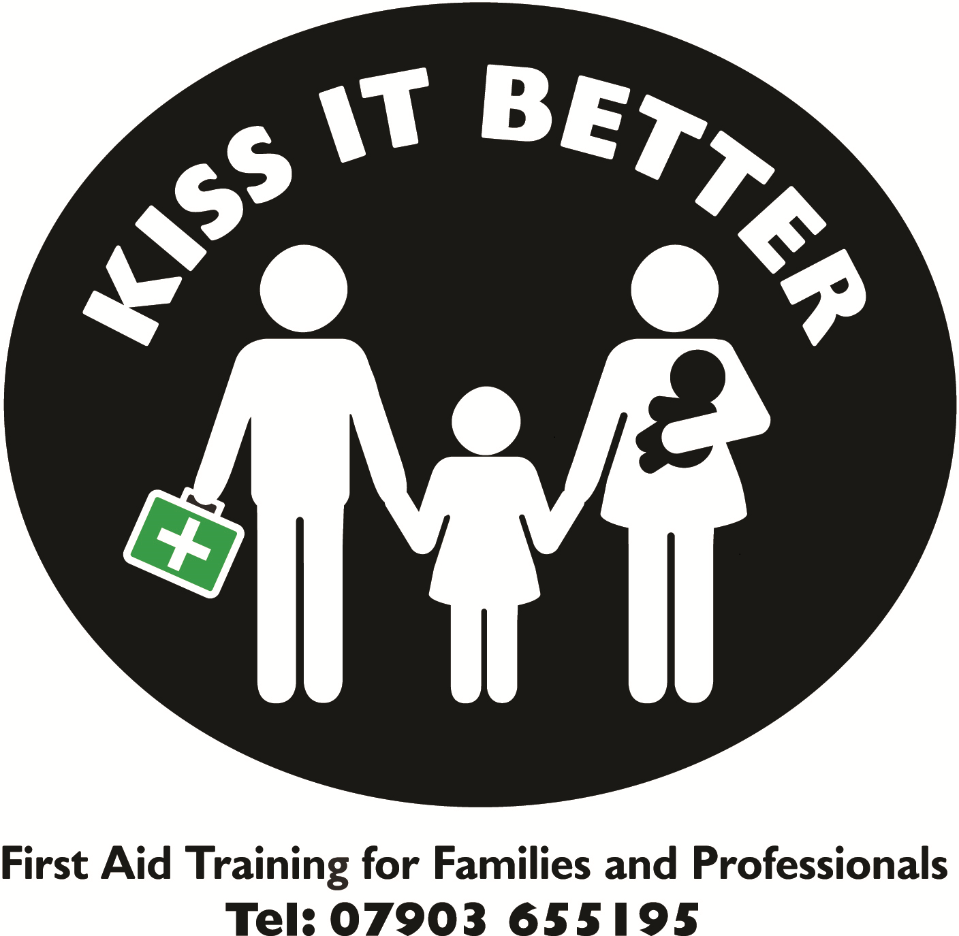

Thank you for enquiring about Kiss It Better First Aid Courses. Please complete the booking form below completing all relevant sections (Up to 3 candidates can be included if completion is within GDPR guidelines). If you, or the person you are booking onto the course has any medical problems, allergies or historical first aid incidents that could affect them on the course please ensure that this information is provided.

Kiss It Better will not share candidates’ personal information provided on this form with any other organisation other than the candidates name when registering with ITC First Ltd (the Awarding Body). However, it is important that you provide me with the best contact details possible in the event of any course disruption (e.g. my personal injury/illness, inclement weather conditions, your non arrival, etc)

Name and Organisation
of the person making the booking
Course Title
Duration
Course Date
Course Time
Venue
Number of Candidates
Total Amount Payable

Candidate Details
Candidates Names:
Home Telephone Number(s) and Contactable Times:
Mobile Telephone Number and Contactable Times:
Email address:
Please note any medical issues/allergies that may impede training or affect the candidate on the course
Please note any past experiences that may be sensitive/difficult for the candidate during training

I confirm that by signing this form I have sought consent from the candidate(s) to share their details with Kiss It Better, and accept the terms and conditions below which includes details of how candidates’ personal information will be used by Kiss It Better. If returning by email your email address acts as your signature. Once completed, please return the form either by email or post to Trudy McLaughlin at the address below. Attaching this form to an email also acts as your electronic signature.

Signature: Date:

Print Name:

Terms and Conditions

1. Confirmation
Course bookings are provisional until a completed booking form has been received by Kiss It Better. Once the completed booking form has been received and processed you will be allocated a space(s) accordingly on the relevant course, and an invoice sent. Your place(s) will be confirmed when payment has been received unless otherwise agreed by Trudy McLaughlin.

2. Fees
Course fees are normally due at the time of booking the course (unless otherwise agreed). Once received joining details and pre-course information will be sent, along with a receipt if requested. In the event that a candidate turns up on the day without prior confirmation they may be turned away if the course is fully subscribed.

3. Cancellation of a course by the client
Cancellation of a course by the Client then the following conditions apply:
- Within and inclusive of 7 days notice the Full Course Fee is due
- 8 days – 21 days 50% of the Course Fee is due
-More than 21 days – a £25.00 administration fee is due
-Failure to attend – the Full Course Fee is due

Cancellation of a course by Kiss It Better:
In the unlikely event of a course being cancelled by Kiss It Better due to unforeseen circumstances Kiss It Better will make every attempt to contact the name on the booking form and/or leave a message/email. Alternative dates will be offered or a full refund given if the invoice has already been paid.

4. Oversubscription
In the unlikely event of the course being oversubscribed, a full refund will be given or alternative course dates provided. If a candidate should turn up on the day without prior confirmation then the candidate will be turned away if the course is fully subscribed.

5. Certificates
(a) Due to the fact that all our courses provide very necessary information throughout all sessions any participants that do not attend all course sessions will not be awarded a certificate.

(b) Any participant taking part in a course that has a pass or fail criteria will not be awarded a Pass certificate if the necessary assessment criteria has not been achieved. A certificate of attendance may be issued if full attendance has been achieved.

(c) Certificates will only be released to clients once payment has been received.

6. Insurance
Kiss It Better holds the relevant insurance to provide first aid courses to protect all clients and participants. Please contact us if you require further details.

7. Responsibilities
(a) First Aid is an active, practical subject. Participants are normally expected to be physically fit enough to kneel, twist and bend over simulated casualties, to sit on the floor, to perform simulated CPR, roll and help roll simulated casualties on the floor. Participants are also required to wear appropriate clothing to carry out the above activities and for lying on the floor and being rolled over as a casualty.

(b) Please bring any possible medical problems to our attention before booking the course. We have a variety of courses, some of which are less active than others, which may be more suitable. We can advise you at this time.

(c) Please supply us with any specific needs or particular requirements. This may be topics you would like us to cover, time allowing, or allergies that may need to be accounted for when providing refreshment.

- Participants are expected to maintain acceptable levels of behaviour. Unacceptable behaviour may lead to offenders being asked to leave. Course fees would not be refunded in this instance.

- Any malicious damage caused by yourself will result in you paying for those items.

8. GDPR and Privacy Information – How Kiss It Better uses your information:

Kiss it Better requires certain information about the candidate for the purpose of registering and facilitating a First Aid course. The information on this booking form will be kept securely for a period of 5 years to facilitate renewal of the qualification in 3 years time and in accordance with the Awarding body ITC First Ltd. For further information please visit www.kissitbetterfirstaid.com/ Privacy Notice

7. Alteration
Alteration to these terms and conditions may occur at any time. Any changes will be passed to all who require knowledge of changes.

